Travelling Route Generation System

Zhang Yong, Li Zhihui, Liu Ziyi

*May 2019*

**Interim Project Report**

Computing Science

University of Hong Kong

# Introduction

With the development of the economy, people's demand for tourism is growing. However, it is very difficult to plan a reasonable, economic and specific travel route in a short period of time. So this system provides a convenient and fast way to plan the travel route for the user. The user only needs to input multiple destinations and the total travelling time and then the system recommends the best travel route based on the comprehensive consideration of the travel route cost. In addition, the system will also plan the detailed route between the travel spots in the city.

## Background and Context

Travel route planning is to develop a route in a certain area, in order to enable visitors to get the maximum viewing effect in the shortest time and have certain characteristics. And the route is reasonably connected by a number of tourist spots or tourist cities by the traffic line.

Under the constraints of attractions, transportation expenses, travel time, and travel locations, how to choose the right and best series of attractions from a variety of attractions, and form a route for tourists to refer to. In terms of applications, it is necessary to combine attractions, itineraries, and routes and maps. When you select an attraction, you can see its location on the map. While planning the itinerary and route, you can also see the distribution of the itinerary and the direction of the route on the map.

## [Scope](http://www.cs.stir.ac.uk/~kjt/research/conformed.html) and Objectives

The principle of determining the tourist route is designed according to the purpose of tourism, the physiological conditions of the tourist subject, the economic and time purchasing power of the tourists, the hobby of the tourists and the special tourism subject.

The traditional tourist attraction recommendation is generally based on the popularity of the attraction or the recommendation algorithm for personalized recommendation, but there are few studies considering the recommendation of the top-level hot spots. In terms of travel route planning, the algorithm for considering both time and cost is still a vacancy between two different points. This paper makes up for the lack of research on the recommendation of popular tourist attractions and multi-factor travel route planning. At the same time, the system integrates the functions from the scenic spots to the route to meet the needs of tourists.

This interim project report is divided into five chapters, each of which reads as follows:

The first chapter introduces the background of the work of this project.

The second chapter introduces related technologies, including clustering algorithms and travel itinerary planning algorithms.

The third chapter details the techniques and algorithms used in the system.

The fourth chapter introduces the prototype demo of the system.

The fifth chapter introduces the schedule of system implementation.

# State-of-The-Art

The travel route planning problem is based on the evolution of the classic TSP problem. The TSP problem is a typical combinatorial optimization problem. At present, there are many researches on TSP in the world. It has been proposed based on the classical algorithm Dijk-stra algorithm, dynamic programming algorithm, branch and bound method, etc., and improved ant colony based on heuristic optimization algorithm. Algorithm, genetic algorithm, simulated annealing algorithm, tabu search algorithm, Hopfieltl neural network, particle swarm optimization algorithm, immune algorithm, etc. In recent years, the research of Chinese domestic scholars mainly focuses on the application and optimization of ant colony algorithm in route planning.

Xu proposed the encounter algorithm based on the classical ant colony algorithm in the article "Improving the application planning of ant colony algorithm in tourism route planning", which effectively improved the quality of the ant colony algorithm. In addition, Xu improved the travel path, so that the ant colony algorithm can achieve dynamic planning.

In the article "Improving the Application of TSP Model in Optimal Tourism Route Planning", Wang proposed an improved TSP model with multiple time constraints in combination with actual tour conditions (such as queuing). Xu has made reasonable adjustments and analysis in light of the various situations that may be encountered in real life.

Yang specifically designed the constraints of tourism route planning in the article "Research on the Planning of Tourism Route Planning in the National 5A Level Scenic Spots". It includes the number of holidays and time requirements for current city residents, combined with time, distance and cost.

On the basis of Yang's research, Wan improved the input variables of the whole system, including latitude and longitude coordinates, ticket fees, best travel routes and accommodation expenses, etc. in the article "Research on 5A Attractions Tourism Route Planning Problem Based on Ant Colony Algorithm". Wan uses the ant colony algorithm to propose four target benefit maximization models for comprehensive time, cost, distance and comfort which improves the accuracy of recommendation.

# Methodology

This part illustrates the methods our website are using so far to implement the system.

## Terminology Definition

Total travel time: the duration of the travel the user needs to input

Itinerary: the route generated by our website

Travel spot: the hot spot we recommend to the user

Play time: the estimated time to visit a certain travel spot

Address of travel spot: the readable address of a travel spot

Location of travel spot: the latitude and longitude representation of a travel spot

## Data Collection

Given a certain destination, our website collects the addresses, play times, ranking of the recommended travel spots.

### Web Crawling

Ranking, address and location of the travel spots are obtained from Ctrip. The play time of the travel spots is obtained from mafengwo.

### API

Baidu map API can provide the information about the travel time and travel between each pair of travel spots.

## Itinerary Generation

Based on the travel spots and total travel time, generate an itinerary for the user. One-day generation algorithm is used to generate

### One-day generation algorithm

This algorithm is used to create the one-day itinerary. It contains three phrases:

1. filter_by_play_time
2. generate_one_day_route

Some assumptions are made when applying the algorithm:

1. a user will start from the hotel and return to the same hotel
2. the hotel and the travel spots nearby are not very far away from each other

Input of the one-day generation algorithm:

1. available travel time of that day
2. the names of all the travel spots
3. play times of each travel spot

Output of the one-day generation algorithm:

1. the itinerary with the names of travel spots
2. recommended play times of each travel spot
3. recommended travel times between each pair of travel spots

Filter_by_play_time:

Compute the maximum k such that the sum of play times of the top k travel spots is less than the available travel time of that day

Generate_one_day_route:

1. Initialize a route list L to empty. Initialize all travel spots to a set TS.
2. If TS is empty, return L and TS.
3. Start from the current location, find the nearest travel spot in TS.
4. If the sum of the travel time to that travel spot, the play time of that travel spot and the travel time from that travel spot to the hotel is less than the available travel time of that day, append that travel spot to L, remove that travel spot from TS, set the current location to that travel spot. Otherwise remove that travel spot from and repeat from b.

### Intercity generation algorithm

To be figured out.

## Website Development

Webpage designs can be seen on chapter four.

# Prototype

We design a web page to showcase our functionality, but we want to simplify the style in the user-selected interface so that the user can truly experience the one-click planning that the feature focuses on. Users do not need to make too many inputs and decisions, just fill in the most basic information.

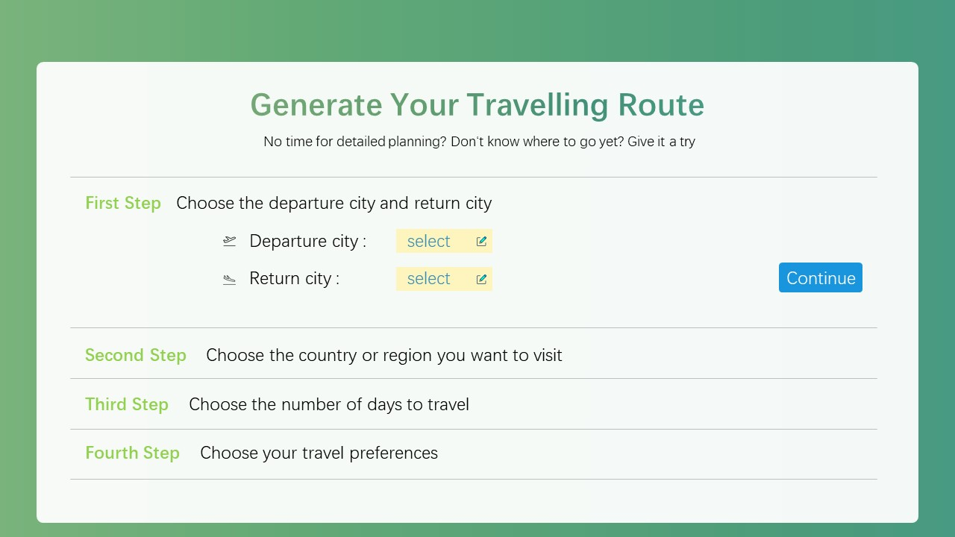

Figure 4.1 Choose the departure and arrival city

We will provide users with some popular places to choose from, ensuring that users can quickly get some inspiration when they have no idea what to choose.

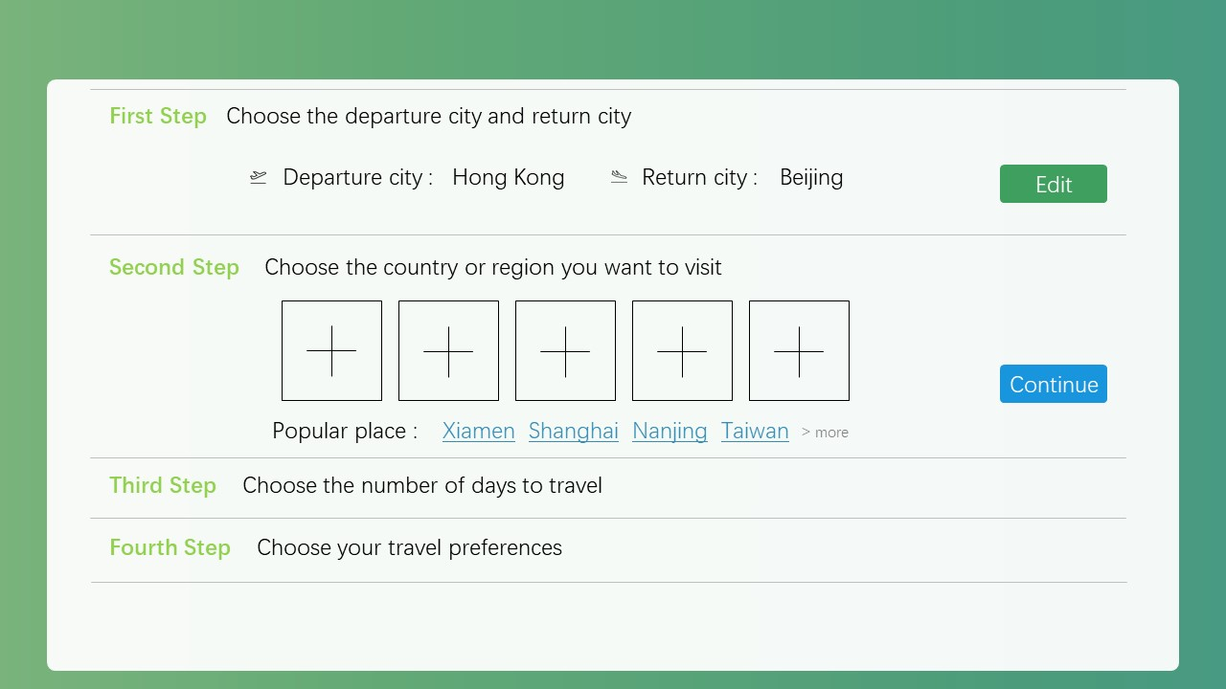

Figure 4.2 Choose where you want to go

When the user does not decide on the departure date, they can tick the option that has not been decided yet, and the system will make the route plan according to the number of travel days.

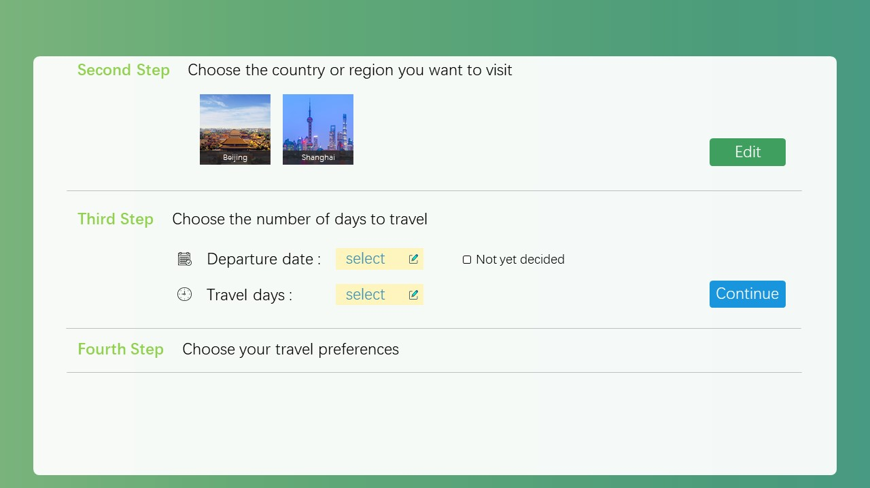

Figure 4.3 Selecting the departure time and travel days

Everyone has different travel habits, so we ask users to choose the travel schedule and hotel situation that suits them. The system chooses moderate travel compactness and ordinary hotels by default.

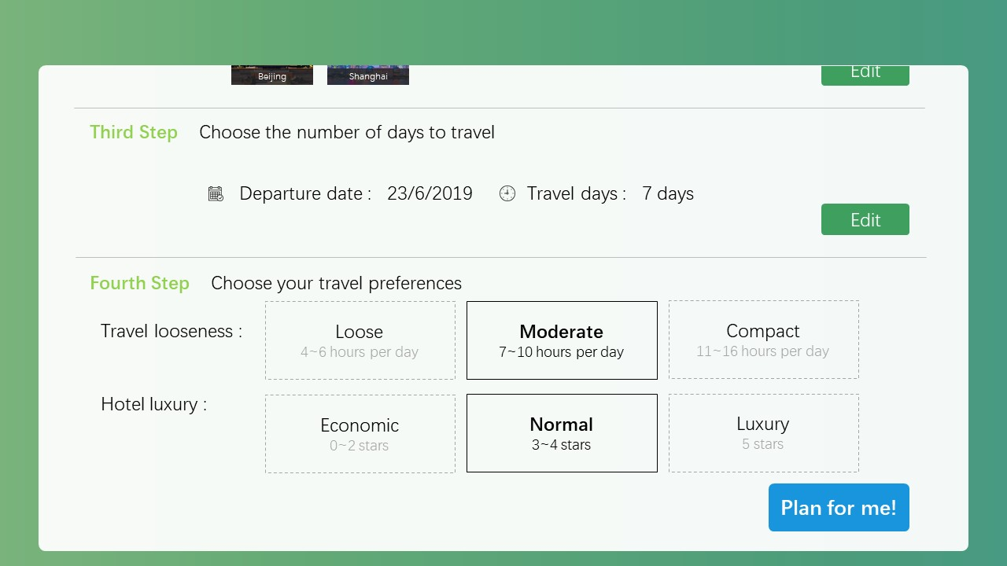

Figure 4.4 Choose Travel Preferences

After clicking Plan for me, the system will generate a planned tour route based on the algorithm. Users can view the itinerary by date, click on the name of the attraction to view the details of the attraction, and view route planning and navigation between the various attractions.

The top of the interface provides local popular tourist attractions, but due to time schedules, some attractions are not planned. The user can click to view the details of the attraction. If the destination that the user wants to go to is not included in the automatically planned itinerary, click Add to plan, and the system will re-route the updated list of attractions.

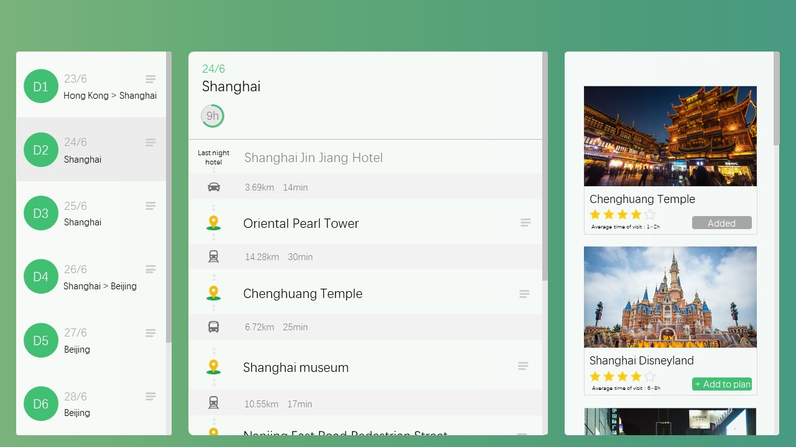

Figure 4.5 Generate travel route planning

# Interim Plan

## Updated Project Plan

**Milestones**

|  |  |  |  |
| --- | --- | --- | --- |
| ***Tasks*** | | ***Estimated completion time*** | ***Estimated number of Learning hours*** |
| 1 | Project web page design | 15/05/2019 | 15 |
| 2 | Data collection and cleaning | 28/05/2019 | 30 |
| 3 | Map implement | 05/06/2019 | 55 |
| 4 | Route optimization algorithm design and implement | 12/06/2019 | 120 |
| 5 | Performance evaluation and development | 23/06/2019 | 80 |
| 6 | Web user interface design | 01/07/2019 | 50 |
| 7 | Prepare presentation PPT | 10/07/2019 | 30 |
| 8 | Write the final report | 01/08/2019 | 50 |
| 9 | Poster design | 15/06/2019 | 20 |
| 10 |  |  |  |
|  |  |  | Total:450 |

## Updated Project Deliverables

Update the remaining deliverables of the project. In particular, describe what you will demonstrate when the final report is due.

**Deliverables**

|  |  |
| --- | --- |
| ***Items*** | |
| 1 | Interim Report |
| 2 | Project Webpage |
| 3 | Poster |
| 4 | Final Project Report |

References

1. Yang J , Shi X , Marchese M , et al. An ant colony optimization method for generalized TSP problem[J]. Progress in Natural Science, 2008.
2. Fuchs H , Kedem Z M , Uselton S P . [ACM Press the 4th annual conference - San Jose, California (1977.07.20-1977.07.22)] Proceedings of the 4th annual conference on Computer graphics and interactive techniques, - SIGGRAPH \"77 - Optimal surface reconstruction from planar contours[J]. Communications of the Acm, 1977.
3. Sakoe H , Chiba S . Dynamic programming algorithm optimization for spoken word recognition[J]. IEEE Transactions on Acoustics, Speech, and Signal Processing, 1978.
4. Norkin V I , Pflug G C , Ruszczynski A . A Branch and Bound Method for Stochastic Global Optimization[J]. Mathematical Programming, 1998.
5. Silva R , Lopes H S , Godoy W . A Heuristic Algorithm Based on Ant Colony Optimization for Multi-objective Routing in Vehicle Ad Hoc Networks[C]// 2013 BRICS Congress on Computational Intelligence & 11th Brazilian Congress on Computational Intelligence (BRICS-CCI & CBIC). IEEE, 2013.
6. Xu Feng. Improving the Application of TSP Model in Optimal Tourism Route Planning [J]. journal6, 2006.
7. Yang Yunpeng, et al. Research on 5A Attractions Tourism Route Planning Problem Based on Ant Colony Algorithm [J]. Practice and understanding of mathematics, 2016.